* 1.  Register-Memory because cmpl compare between register and memory.
  2.  Restricted Alignment because int is 4 bytes but to allocate double that is 8 bytes, it allocates at 24 instead of 20 mean that it’s Restricted Alignment.

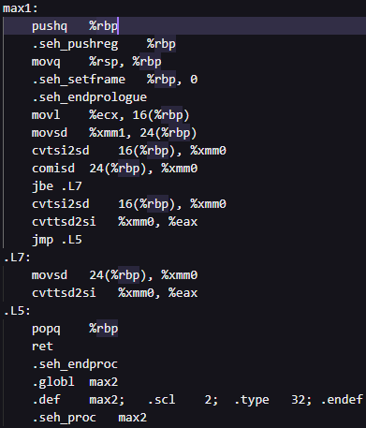

* 1. Callee saves as this picture.
  2. Pass by register where %ecx and %edx for function argument and %eax for return value.

Firstly, let’s return value be a. Then compare a and b if b is higher than a then write return value to be b.

First cmpl use for comparing if b < a and set %al to 1 if it’s true else 0.

Second cmpl use to select which bracket to work. If a > b will not jump and do first bracket else will jump to L4 and do second bracket.

* 1. A screen shot of a computer

     Description automatically generatedA screenshot of a computer program

     Description automatically generated max1 and max2 are now same it just write first argument to return value then check if it must overwrite with second argument in case if b > a.
  2. A screenshot of a computer program

     Description automatically generatedA screenshot of a computer

     Description automatically generated All of operation use 1 CPI except cmpl, cmovge, add and ret use 2 CPI. So, I use 12 clocks for each loop call max1 which is around 1 / 5.4G \* 21 = 3.89 nanosecond but it’s use 3.51 millisecond. After I make loop to call max1 10^6 times it uses 4.12 millisecond so in average it uses around 4 nanoseconds for each loop to call max1 function.

2) Based on average 10 time the result is:

- Optimize 0: 6.8745 second.

- Optimize 1: 6.9963 second.

- Optimize 2: 3.7274 second.

- Optimize 3: 3.7762 second.

3) On each optimize level:

- Optimize 0: Normal Assembly.

- Optimize 1: Optimize branching which can easily be seen in looping call fibo and remove many unnecessary Register-Memory commands such as movl and allocate less stack.

- Optimize 2: Now, it’s start using xor to optimize some trick like set register to 0 by xorl itself faster than movl 0 to its. And use less stack use more register which use less clock mean faster. Also remove redundant movl and change where loop call fibo is. As a result, run time is significantly reduced.

- Optimize 3: Heavily optimize loop and logical flow which we can see that fibo part is still same but flow to loop call main fibo then print is now change to minimum redundant part that don’t have to recheck.